IT’S SCHOOL PORTRAIT TIME!

Grass Lake
8th Grade Graduation

Wednesday, February 7th

SEND NO MONEY ON PICTURE DAY

Each child will be photographed twice.
- A ¾ length Graduation Gown photo and
- A ¾ length photo in their casual clothes.
A proof envelope will be sent back to the school with proofs and pricing information.

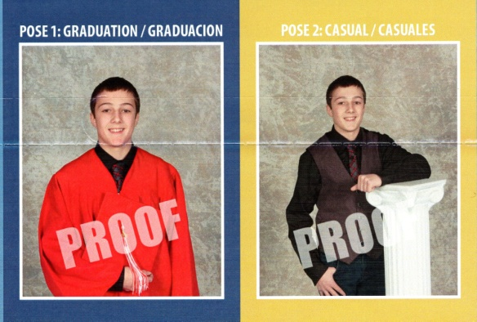
CLOTHING
Please send your child dressed for 8th Grade Picture Day. Please remember that these are ¾ length portraits so your whole outfit will show except for your shoes.

Please remember: proper clothing allows the face to dominate the portrait, with all other elements being secondary. Patterns tend to overpower a portrait and distract from the focus of the face. Darker colors and coordinated outfits will photograph better. Please no messages on your shirts.

ORDERING
Review the proofs and price information, complete the order form and return it to the school to his/her teacher by the due date.
Or use the information on the proof envelope to go online to purchase your child’s portraits before the due date listed on the proof envelope.

Late orders are subject to a late fee and delayed delivery.

QUESTIONS??

Ed Clark Photography 847-231-4444

